Open SAE J1939

Foreword
SAE J1939 is a protocol for shaping the CAN-bus message in a specific way that suits industrial vehicles such as tractors, machinery, trucks and more.

SAE J1939 is a very easy protocol to use, but there is a lack of information about SAE J1939, due to the cost of the protocol document, available how to shape a CAN-bus message according to SAE J1939 protocol standard. So therefore I’m writing a SAE J1939 protocol available for free to use on any embedded systems such as STM32, Arduino, AVR, PIC etc.

To learn to build on this project, you need first to understand SAE J1939. I have written this project in C language because C is an industry standard. The C language dialect I have chosen is C99 and I don’t use dynamical memory allocation in this library. So it will work with MISRA C standard.

With this library, you can communicate with valves, engines, actuators, hardware and all other things that are suitable for heavy industrial mobile applications. I have build up a basic structure of the project and I hope that other users will send pull request of their C code for extra functionality to SAE J1939 standard because SAE J1939 is a huge standard.

- Daniel Mårtensson, Sweden, 2021-07-14

Table of Contents
Foreword 1
Quick introduction to SAE J1939 ID and DATA 2
Functionality overview of Open SAE J1939 3
Open SAE J1939 4
Listen For Messages 4
SAE J1939:71 Application Layer 4
Request Software ID 4
Request Component ID 4
Request ECU ID 4
ISO 11783-7 Application Layer 4
SAE J1939:73 Diagnostics Layer 4
SAE J1939:81 Network Layer 5
SAE J1939:21 Transport Layer 5
SAE J1939 Protocol 5
Request 5
Acknowledgement 6
Transport Protocol Connection Management 7
Transport Protocol Data Transfer 9
Address Claimed 9
Address not claimed 11
Commanded Address 12
Delete Address 12
DM1 13
DM2 15
DM3 16
DM11 – Not supported 16
Software identification 16
ECU identification 16
Component identification 17
DM14 & DM15 and DM16 18
ISO 11783 Protocol 21
ISO 11783-7 Application Layer 21
Auxiliary Valve Command 21
General Purpose Valve Command 22
Auxiliary Valve Estimated Flow 23
General Purpose Valve Estimated Flow 24
Auxiliary Valve Measured Position 25

Quick introduction to SAE J1939 ID and DATA
First you need to understand the data frame of SAE J1939. The data frame of SAE J1939 is basically one ID and one DATA. ID and DATA is the information we are going to send through the CAN-bus network.
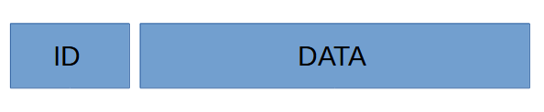Figure 1: SAE J1939 Data frame

ID contains 4 hex values and DATA contains maximum 8 hex values e.g 8 bytes values.
An ID can be shaped as this 0x18FE8022 where 80 is the destination address, called DA and 22 is the source address, called SA. So you more likely going to see ID numbers as this 0x18FE’DA’’SA’

The DA address and SA address is the addresses of the ECU – Electronic Control Unit, e.g microcontroller/PCB board. You self decide what address your ECU should have. For example. If you have two ECU that are going to communicate to each other. Then you have for example ECU1 address as 0xA1 and ECU2 as 0xA5. If ECU1 what to send a message to ECU2, then the destination address DA would be 0xA5 and the source address SA would be 0xA1. If ECU2 want to send a message to ECU1, then DA would be 0xA1 and source address SA would be 0xA5.

So keep that in mind that when I’m talking about SA and DA, it’s only about source address and destination address of the ECU. When it comes to the rest of the ID values 0x18FE, they are just there to describe the type of message. Each message have a unique ID and therefore the ID will be shaped differently. Sometimes, DA in the ID message is replaced by a unique hex value.

The length of DA and SA are from 0x0 to 0xFD because 0xFE is error address and 0xFF is broadcast address.

DATA is just 8 bytes of data. DATA holds information about anything the user want to send to other ECU. Sometimes DATA can be 3 bytes depending on if we are sending a unique message.

Functionality overview of Open SAE J1939
Open SAE J1939 is just basic C-code, arrays, function, structures and bitwise operations. Nothing more. I have shaped this project according to this map below. This map describe basic overview of the project. Some functions may have been added after this document was made, but the structure is the same. Those functions are inside the green box and they are called extra functionality of the project.
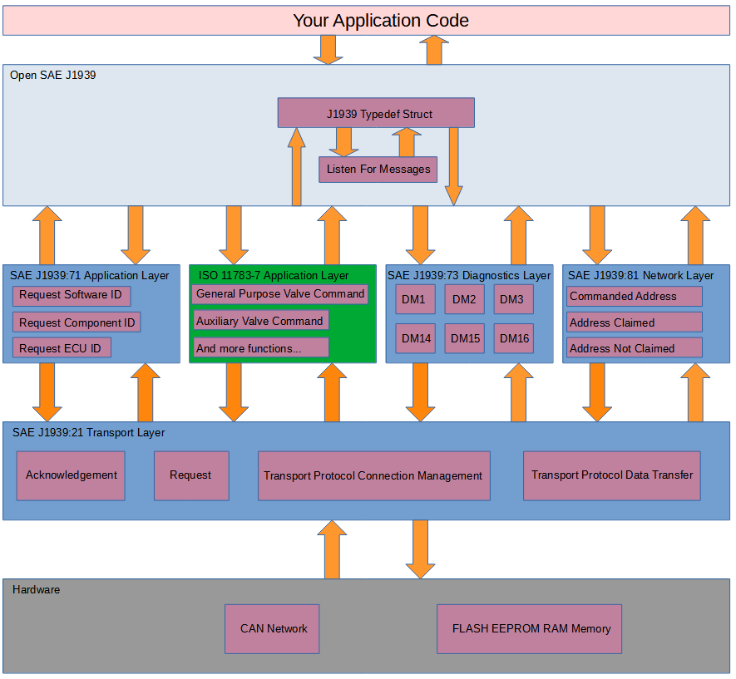Figure 2: Structure of this project
We begin from the top. The J1939 Typedef Struct. That structure is just a basic C code typedef struct that holds information about all ECU who are connected to the CAN-network. The struct can be found at the Open SAE J1939 folder.
The idea behind the struct:
- The struct holds source address of all ECU
- The user are going to create a C pointer of the struct and pass it to the SAE J1939 functions, like an object where the user pass that object as argument in the functions. So you can interpret that object as likely basic OOP in C.
- The struct hold temporary information about other ECU
- The struct hold information about their own ECU
- The struct holds the source address from where the message came from

Open SAE J1939

Listen For Messages
This function is called all the time by the user. Most likely inside a while loop. This function reading ID and DATA directly and split ID into 4 different ID for determine what kind of ID it is and what to do next. It split up ID, check what ID it is and then check what function it want to call and then pass that DATA + source address SA + pointer of the struct to that function as argument. That’s it. Listen For Messages is just a function who select which function we want to call, depending on how the ID looks like.

SAE J1939:71 Application Layer

Request Software ID
Every ECU has a software ID for example a number or a text that describe for example BIOS software or software version. Call this function if you want to request the software ID from other ECU. The ECU will then response back to you with information.

Request Component ID
Every ECU has a component it control. It can be for example a motor, valve or other thing. Call this function if you want the ECU to send information about the component that ECU controls.

Request ECU ID
Same as above. Call this function if you want to know the ID information about the ECU you are sending to.

ISO 11783-7 Application Layer
Here I have selected the application layer of agriculture, tractors and machinery ISO standard. That application layer contains these functions:
- General Purpose Valve command – Sending control messages to ECU for controlling valves
- Auxiliary Valve Command – Sending control messages to ECU for controlling valves
- General Purpose Valve Estimated Flow – Get the computed flow from a valve
- Auxiliary Valve Estimated Flow – Get the computed flow from a valve
- Auxiliary Valve Estimated Position – Get the computed position of the valve main spool

SAE J1939:73 Diagnostics Layer
Diagnostics layer contains messages about errors, but it also can contains functionality such as memory access of the EEPROM (built in “hard drive”) or command for deleting error messages.
- DM1 – Contains error messages such as electrical fault, location etc
- DM2 – Contains previous active DM1 messages
- DM3 – Deleting DM2 messages
- DM14 – Memory request of bytes, address etc from a ECU
- DM15 – Memory response from a DM14 request from that ECU
- DM16 – Binary data transfer (if DM15 repose was OK)

SAE J1939:81 Network Layer
At the startup of an ECU, the ECU sending Address Claimed, which means it giving out the information about something called NAME. NAME is basic information about the ECU + SA.

- Address Claimed – Send out NAME + ID that holds SA.
- Address Not Claimed – Send out NAME + ID that holds Address Not Claimed.
- Commanded Address – Send this to an ECU and you can change its NAME and SA.
- Delete Address – Send a command to other ECU or all ECU for deleting a specific address. This is not SAE J1939 standard.

SAE J1939:21 Transport Layer
- Acknowledgement – Send a OK, BUSY, WAIT etc. as a response on a request.
- Request – Asking information or functionality about an ECU.
- Transport Protocol Connection Management – Send how much data in packages you want to send to the receiver.
- Transport Protocol Data Transfer – Send the data in packages to the receiver.

SAE J1939 Protocol

Request
Request are used when we want to ask an ECU of “something”. That “something” is a PGN number. Enter a PGN number, send the message and get a response from that ECU directly. All PGN numbers can be found in Enum_PGN.h
Message ID | 18 EA "DA" "SA"
PGN | 0x00EA00 (59904)
Peer to Peer/Broadcast | Peer to Peer or Broadcast with DA = 0xFF (Used for Address Claimed)
Message length | 3 bytes
Multipacket | No
Byte 1 | PGN LSB
Byte 2 | PGN
Byte 3 | PGN MSB

Field | Max value | Min value | Explanation | Enum
PGN | 0x0 | 0xFFFFFF | Request command | Enum_PGN.h

In case you did not understand what LSB and MSB is. LSB stands for least signifiant bit and MSB stands for most signifiant bit. LSB means the lowest number and MSB means the highest number. If we want to send the PGN number 0x18EEA1, then the LSB is 0xA1 because that’s the lowest number and MSB is 0x18 because that’s the highest number. The same reason when you write out 1024 where you begin with highest number 1(1000), then 0(000), then 2(20) and last 4. 1000 + 000 + 20 + 4 = 1024. So keep that in mind that MSB is the highest number and LSB is the lowest number.

Acknowledgement
Acknowledgement are used when we want to response back to an ECU e.g completed, busy, not available etc.
Message ID | 18 E8 "DA" "SA"
PGN | 0x00E800 (59392)
Peer to Peer/Broadcast | Peer to Peer
Message length | 8 bytes
Multipacket | No
Byte 1 | Control byte
Byte 2 | Group function value
Byte 3 | 0xFF (Reserved)
Byte 4 | 0xFF (Reserved)
Byte 5 | Address
Byte 6 | PGN of requested info LSB
Byte 7 | PGN of requested info
Byte 8 | PGN of requested info MSB

Field | Max value | Min value | Explanation | Enum
Control byte | 0x0 | 0xFF | Describes the status of the requested PGN | Enum_Control_Byte.h
Group function value | 0x0 | 0xFF | The function code that specify the cause of the control byte | Enum_Group_Function_Value.h
Address | 0x0 | 0xFF | The source address of the ECU from where the acknowledgement came from
PGN of requested info | 0x0 | 0xFFFFFF | The same PGN number in the request | Enum_PGN.h

Transport Protocol Connection Management
This describe for the receiver ECU how many packages and total size of data we are going to send via Transport Protocol Data Transfer.
Message ID | 1C EC "DA" "SA"
PGN | 0x00EC00 (60416)
Peer to Peer/Broadcast | Peer to Peer
Message length | 8 bytes
Multipacket | No
Byte 1 | Control byte
Byte 2 | Total message size LSB
Byte 3 | Total message size MSB
Byte 4 | Number of packages
Byte 5 | 0xFF (Reserved)
Byte 6 | PGN of the packeted message LSB
Byte 7 | PGN of the packeted message
Byte 8 | PGN of the packeted message MSB

Field | Max value | Min value | Explanation | Enum
Control byte | 0x0 | 0xFF | Describes how the data transfer should become | Enum_Control_Byte.h
Total message size | 0x9 | 0x6F9 | Total bytes we are going to transfer
Number of packages | 0x2 | 0xE0 | How many packages are we going to transfer
PGN of the packeted message | 0x0 | 0xFFFFFF | The type of information we are sending | Enum_PGN.h

Here is two way to send a multi pack messages:

- BAM – Just send the message to the ECU
- RTS/CTS – Wait for a response (With an acknowledgement response at the end)
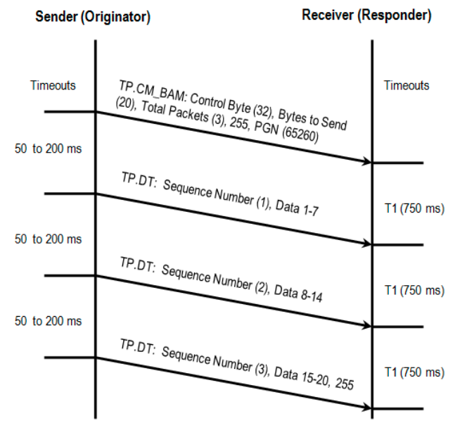Figure 3: Broadcast Announce Message(BAM)
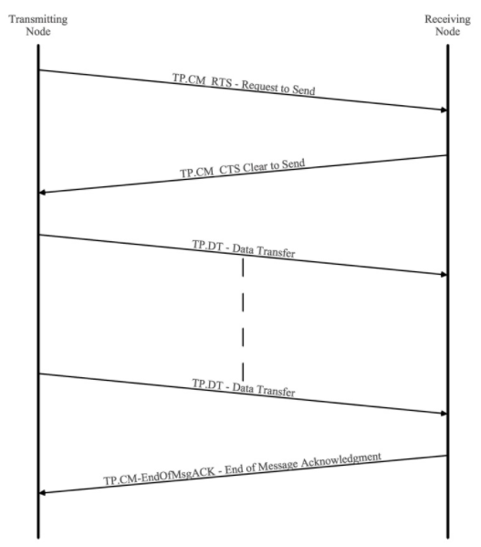Figure 4: Request To Send(RTS), Clear To Send(CTS) and EndOfMsgACK

Transport Protocol Data Transfer
This sending packages to the receiver ECU. Transport Protocol Connection Management must be sent first. Else the receiver won’t know how many packages and total data and PGN number we the transmitter is sending.
Message ID | 1C EB "DA" "SA"
PGN | 0x00EB00 (60160)
Peer to Peer/Broadcast | Peer to Peer
Message length | 8 bytes
Multipacket | No
Byte 1 | Sequence number
Byte 2 | Data 1
Byte 3 | Data 2
Byte 4 | Data 3
Byte 5 | Data 4
Byte 6 | Data 5
Byte 7 | Data 6
Byte 8 | Data 7

Field | Max value | Min value | Explanation | Enum
Sequence number | 0x0 | 0xE0 | This is the order/index of the data transfer packages
Data 1 to Data 7 | 0x0 | 0xFF | Your data bytes

Address Claimed
This describes the NAME about the ECU, and also the other ECU get to know its SA.

Message ID | 18 EE FF "SA"
PGN | 0x00EE00 (60928)
Peer to Peer/Broadcast | Broadcast
Message length | 8 bytes
Multipacket | No
Repetition rate | Sent at power on, after a “Request” for “Address Claim” and after a “Commanded Address”
Byte 1 | Identity number LSB
Byte 2 | Identity number
Byte 3 | Manufacturer code LSB [8..6], Identity number MSB [5..1]
Byte 4 | Manufacturer code MSB
Byte 5 | Function instance [8..4], ECU Instance [3..1]
Byte 6 | Function
Byte 7 | Vehicle system [8..2], 0x1 (Reserved) [1]
Byte 8 | Arbitrary address capable [8], Industry group [7..5], Vehicle system instance [4..1]

Notice that [X..Y] describes the bit index in the byte. It more likely looks like this.
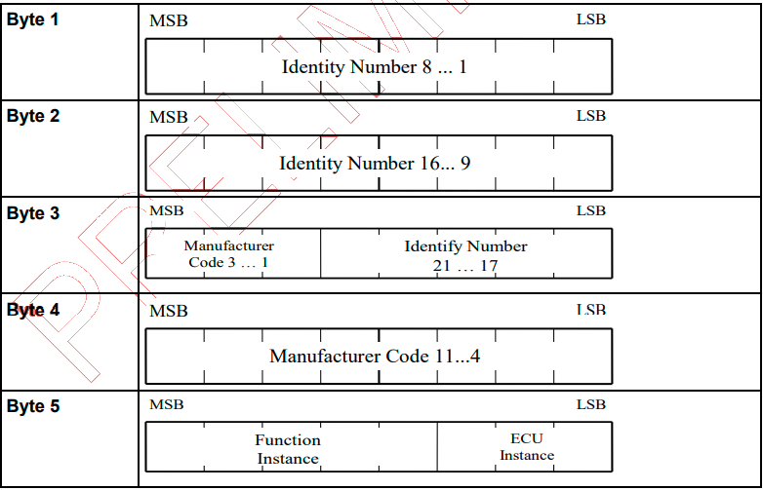Figure 5: How to interpret
Field | Max value | Min value | Explanation | Enum
Identity number | 0x0 | 0x1FFFFF | ECU identity number
Manufacturer code | 0x0 | 0x7FF | ECU manufacturer code
Function instance | 0x0 | 0x1F | ECU function area
ECU instance | 0x0 | 0x7 | ECU function area
Function | 0x0 | 0xFF | ECU functionality | Enum_NAME.h
Vehicle system | 0x0 | 0x7F | Where in the vehicle system the ECU is located
Arbitrary address capable | 0x0 | 0x1 | If the ECU have right to change address if the address conflicts with another ECU | Enum_NAME.h
Industry group | 0x0 | 0x7 | Where in the industry the ECU is located | Enum_NAME.h
Vehicle system instance | 0x0 | 0xF | The vehicle system code

Address not claimed
When an ECU cannot claim their address, the other ECU will receive this message. The user don’t know which ECU cannot claim their address. The user can only see the amount of how many ECU could not claim their address and the NAME of the ECU who could not claim its address. To find which name, just look at the ECU address 0xFE. See the uint8_t variable number_of_cannot_claim_address inside the struct J1939.

Message ID | 18 EE FF FE
PGN | 0x00EE00 (60928)
Peer to Peer/Broadcast | Broadcast
Message length | 8 bytes
Multipacket | No
Repetition rate | Sent if ECU address conflicts with other addresses
Byte 1 | Identity number LSB
Byte 2 | Identity number
Byte 3 | Manufacturer code LSB [8..6], Identity number MSB [5..1]
Byte 4 | Manufacturer code MSB
Byte 5 | Function instance [8..4], ECU Instance [3..1]
Byte 6 | Function
Byte 7 | Vehicle system [8..2], 0x1 (Reserved) [1]
Byte 8 | Arbitrary address capable [8], Industry group [7..5], Vehicle system instance [4..1]

Commanded Address
This command is used when the user want to change the NAME + SA at an ECU. Notice that this PGN don’t have an ID because Commanded Address DATA is 9 bytes and therefore using transport protocol data transfer.
PGN | 0x00FED8 (65240)
Peer to Peer/Broadcast | Peer to Peer
Message length | 8 bytes
Multipacket | Yes. Use Transport Protocol Connection Management → Transport Protocol Data Transfer
Byte 1 | Identity number LSB
Byte 2 | Identity number
Byte 3 | Manufacturer code LSB [8..6], Identity number MSB [5..1]
Byte 4 | Manufacturer code MSB
Byte 5 | Function instance [8..4], ECU Instance [3..1]
Byte 6 | Function
Byte 7 | Vehicle system [8..2], 0x1 (Reserved) [1]
Byte 8 | Arbitrary address capable [8], Industry group [7..5], Vehicle system instance [4..1]
Byte 9 | New ECU address

Field | Max value | Min value | Explanation | Enum
New ECU address | 0x0 | 0xFD | New address of the ECU

Delete Address
This is not a SAE J1939 standard. It’s made up by me. The reason is that I cannot find an ECU that deletes an address. Because Open SAE J1939 library remembers all the ECU addresses of other ECU addresses. Just to have the ability to count how many are connected and how many are not connected. Good to know. I have looked up the PGN at ISOBUS and I haven’t found any PGN with the number 2. So I guess it’s free for me to use then.
Message ID | 00 02 "DA" "SA"
PGN | 0x000002 (2)
Peer to Peer/Broadcast | Peer to Peer or Broadcast with DA = 0xFF (Used if the user want all ECU to delete a specific address for example after Commanded Address)
Message length | 8 bytes
Multipacket | No
Byte 1 | Old ECU address
Byte 2 | 0xFF (Reserved)
Byte 3 | 0xFF (Reserved)
Byte 4 | 0xFF (Reserved)
Byte 5 | 0xFF (Reserved)
Byte 6 | 0xFF (Reserved)
Byte 7 | 0xFF (Reserved)
Byte 8 | 0xFF (Reserved)

Field | Max value | Min value | Explanation | Enum
Old ECU address | 0x0 | 0xFD | This ECU address is going to disapear from ECU_address[255] array in J1939 struct

DM1
Diagnostics of error and location of an ECU. Notice that this message ID don’t have a destination address because it’s a broadcast message to all ECU.
Message ID | 18 FE CA "SA"
PGN | 0x00FECA (65226)
Peer to Peer/Broadcast | Broadcast
Message length | 8 bytes
Multipacket | No: Normal transfer  Yes: Use Transport Protocol Connection Management → Transport Protocol Data Transfer
Repetition rate | - On request from other ECU  - When an error becomes active
Byte 1 | SAE Lamp status malfunction indicator [8..7],  SAE Lamp status red stop [6..5],  SAE Lamp status amber warning [4..3],  SAE lamp status protect lamp [2..1]
Byte 2 | SAE Flash lamp malfunction indicator [8..7],  SAE Flash lamp red stop [6..5],  SAE Flash lamp amber warning [4..3],  SAE Flash lamp protect lamp [2..1]
Byte 3 | SPN LSB
Byte 4 | SPN
Byte 5 | SPN MSB [8..6], FMI [5..1]
Byte 6 | SPN conversion method [8], Occurrence count[7..1]
Byte 7 | 0xFF (Reserved)
Byte 8 | 0xFF (Reserved)

Field | Max value | Min value | Explanation | Enum
SAE Lamp status malfunction indicator | 0x0 | 0x1 | SAE lamp indicates fault
SAE Lamp status red stop | 0x0 | 0x1 | SAE lamp becomes red
SAE Lamp status amber warning | 0x0 | 0x1 | SAE lamp warns with amber light
SAE lamp status protect lamp | 0x0 | 0x1 | SAE lamp lights up the protection light
SAE Flash lamp malfunction indicator | 0x0 | 0x1 | SAE flash lamp indicates fault
SAE Flash Lamp red stop | 0x0 | 0x1 | SAE flash lamp becomes red
SAE Flash Lamp amber warning | 0x0 | 0x1 | SAE flash lamp warns with amber light
SAE Flash lamp protect lamp | 0x0 | 0x1 | SAE flash lamp lights up the protection light
SPN | 0x0 | 0x7FFFFF | Suspect Parameter Number – Location of the fault | Enum_DM1_DM2.h
FMI | 0x0 | 0x1F | Failure Mode Identifier – What cause the fault | Enum_DM1_DM2.h
SPN Conversion method | 0x0 | 0x1 | 1 = Diagnostics Trouble Code are aligned using a newer conversion method. 0 = One of the three Diagnostics Trouble Code conversion methods is used and ECU manufacture shall know which of the three methods is used
Occurence count | 0x0 | 0x7E | Count how often the DM1 error message becomes active

DM2
DM2 is the previous active DM1 messages. Them shares the same SPN and FMI codes.
Message ID | 18 FE CB "SA"
PGN | 0x00FECB (65227)
Peer to Peer/Broadcast | Broadcast
Message length | 8 bytes
Multipacket | No: Normal transfer  Yes: Use Transport Protocol Connection Management → Transport Protocol Data Transfer
Repetition rate | - On request from other ECU  - On request for DM3
Byte 1 | SAE Lamp status malfunction indicator [8..7],  SAE Lamp status red stop [6..5],  SAE Lamp status amber warning [4..3],  SAE lamp status protect lamp [2..1]
Byte 2 | SAE Flash lamp malfunction indicator [8..7],  SAE Flash lamp red stop [6..5],  SAE Flash lamp amber warning [4..3],  SAE Flash lamp protect lamp [2..1]
Byte 3 | SPN LSB
Byte 4 | SPN
Byte 5 | SPN MSB [8..6], FMI [5..1]
Byte 6 | SPN conversion method [8], Occurrence count[7..1]
Byte 7 | 0xFF (Reserved)
Byte 8 | 0xFF (Reserved)

DM3
DM3 is a request to clear DM2 messages. Use the request function above. After this is done, DM2 will be sent to all ECU via broadcast.
PGN | 0x00FECC (65228)

DM11 – Not supported
DM11 is a request for clearing DM1 messages. The reason why I don’t have implement it, is because in my opinion, it’s just an administrative burden that other ECU need to clear the DM1 error codes. I want the ECU it self to clear their own DM1 codes. The same way it activate the error codes by it self.

Software identification
Send out the software ID of the ECU. Notice that DA here in the message ID is not destination address. It’s the hex value 0xDA.
Message ID | 18 FE DA "SA"
PGN | 0x00FEDA (65242)
Peer to Peer/Broadcast | Broadcast
Message length | 8 bytes
Multipacket | No: Normal transfer  Yes: Use Transport Protocol Connection Management → Transport Protocol Data Transfer
Repetition rate | On request from other ECU
Byte 1 | Number of fields
Byte 2-N | Identification

Field | Max value | Min value | Explanation | Enum
Number of fields | 0x0 | 0x1E | How many fields we are going to transfer
Identification 1 to N | 0x0 | 0xFF | Each identification is one byte e.g ASCII

ECU identification
Send out ECU identification to the ECU.
Message ID | 18 FD C5 "SA"
PGN | 0x00FDC5 (64965)
Peer to Peer/Broadcast | Broadcast
Message length | 8 bytes
Multipacket | No: Normal transfer  Yes: Use Transport Protocol Connection Management → Transport Protocol Data Transfer
Repetition rate | On request from other ECU
Byte 1 | ECU part number
Byte 2 | ECU serial number
Byte 3 | ECU location
Byte 4 | ECU type
Byte 5 | 0xFF (Reserved)
Byte 6 | 0xFF (Reserved)
Byte 7 | 0xFF (Reserved)
Byte 8 | 0xFF (Reserved)

Notice that there are a field called length_of_each_field in ECU_identification inside the J1939 struct. If length_of_each_field = 1, then this message is going to be transfer in a normal way, else multipacket.
Field | Max value | Min value | Explanation | Enum
ECU part number | 0x0 | 0xFF | The part number in ASCII format
ECU serial number | 0x0 | 0xFF | The serial number in ASCII format
ECU location | 0x0 | 0xFF | The location in ASCII format
ECU type | 0x0 | 0xFF | The type in ASCII format

Component identification
Send out component identification to the ECU.
Message ID | 18 FE EB "SA"
PGN | 0x00FEEB (65259)
Peer to Peer/Broadcast | Broadcast
Message length | 8 bytes
Multipacket | No: Normal transfer  Yes: Use Transport Protocol Connection Management → Transport Protocol Data Transfer
Repetition rate | On request from other ECU
Byte 1 | Component product date
Byte 2 | Component model name
Byte 3 | Component serial number
Byte 4 | Component unit name
Byte 5 | 0xFF (Reserved)
Byte 6 | 0xFF (Reserved)
Byte 7 | 0xFF (Reserved)
Byte 8 | 0xFF (Reserved)

Notice that there are a field called length_of_each_field in Component_identification inside the J1939 struct. If length_of_each_field = 1, then this message is going to be transfer in a normal way, else multipacket.
Field | Max value | Min value | Explanation | Enum
Component product date | 0x0 | 0xFF | The product date in ASCII format
Component model name | 0x0 | 0xFF | The model name in ASCII format
Component serial number | 0x0 | 0xFF | The serial number in ASCII format
Component unit name | 0x0 | 0xFF | The unit name in ASCII format

DM14 & DM15 and DM16
DM14 is a memory request. DM15 is a memory response for the DM14 memory request and if DM15 response was proceeded, then DM16 data transfer is called next.
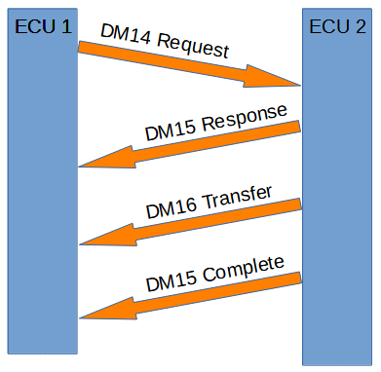Figure 5: DM14, DM15 and DM16
DM14 memory request:
Message ID | 18 D9 "DA" "SA"
PGN | 0x00D900 (55552)
Peer to Peer/Broadcast | Peer to Peer
Message length | 8 bytes
Multipacket | No
Byte 1 | Number of requested bytes LSB
Byte 2 | Number of requested bytes MSB [8..6], Pointer type [7], Command [6..3], 0x1 (Reserved) [1]
Byte 3 | Pointer LSB
Byte 4 | Pointer
Byte 5 | Pointer MSB
Byte 6 | Pointer extension
Byte 7 | Key LSB
Byte 8 | Key MSB

Field | Max value | Min value | Explanation | Enum
Number of requested bytes | 0x0 | 0xFF | The question of how many bytes the ECU want to have
Pointer type | 0x0 | 0x1 | 0 if Pointer and Pointer extension are together one addresses. 1 if pointer is an address and Pointer extension is a way to describe a function code | Enum_DM14_DM15.h
Command | 0x0 | 0x7 | The command what to do | Enum_DM14_DM15.h
Pointer | 0x0 | 0xFFFFFF | The memory address
Pointer extension | 0x0 | 0xFF | Extra memory address, or it can be a function code | Enum_DM14_DM15.h
Key | 0x0 | 0xFFFF | Password or no password at all | Enum_DM14_DM15.h

DM15 memory response of the DM14 memory request:

Message ID | 18 D8 "DA" "SA"
PGN | 0x00D800 (55296)
Peer to Peer/Broadcast | Peer to Peer
Message length | 8 bytes
Multipacket | No
Repetition rate | On request from other ECU
Byte 1 | Number of allowed bytes LSB
Byte 2 | Number of allowed bytes MSB [8..6], 0x1 (Reserved) [7], Status [6..3], 0x1 (Reserved) [1]
Byte 3 | EDC parameter LSB
Byte 4 | EDC parameter
Byte 5 | EDC parameter MSB
Byte 6 | EDCP extension
Byte 7 | Seed LSB
Byte 8 | Seed MSB

Field | Max value | Min value | Explanation | Enum
Number of allowed bytes | 0x0 | 0xFF | The question of how many bytes the ECU is going to have
Status | 0x0 | 0x7 | The response status of the request | Enum_DM14_DM15.h
EDC parameter | 0x0 | 0xFFFFFF | This is an explanation of the status response | Enum_DM14_DM15.h
EDCP extension | 0x0 | 0xFF | This is an explanation of the EDC parameter | Enum_DM14_DM15.h
Seed | 0x0 | 0xFFFF | Status of the key request | Enum_DM14_DM15.h

DM16 is binary data transfer:

Message ID | 18 D7 "DA" "SA"
PGN | 0x00D700 (55040)
Peer to Peer/Broadcast | Peer to Peer
Message length | 8 bytes
Multipacket | No: Normal transfer  Yes: Use Transport Protocol Connection Management → Transport Protocol Data Transfer
Byte 1 | Number of occurrences
Byte 2-256 | Raw binary data 1-255

Field | Max value | Min value | Explanation | Enum
Number of occurrences | 0x0 | 0xFF | How many raw binary data we have
Raw binary data 1-255 | 0x0 | 0xFF | Data to transfer

ISO 11783 Protocol

ISO 11783-7 Application Layer
This ISO standard is for agriculture, tractors and machinery.

Auxiliary Valve Command
Auxiliary valve command is a command from an ECU to broadcast to all other ECU. All it does it to tell other ECU which valve they are going to use and how they are going to use it. Maximum 16 valve numbers can be used, from 0 to 15 according to ISO 11783-7 standard.
Message ID | 0C FE (30+valve number) "SA"
PGN | 0x00FE(30+valve number) (65072+valve number)
Peer to Peer/Broadcast | Broadcast
Message length | 8 bytes
Multipacket | No
Byte 1 | Standard flow
Byte 2 | Fail safe mode [8..7], 0x3 (Reserved) [6..5], Valve state [4..1]
Byte 3 | 0xFF (Reserved)
Byte 4 | 0xFF (Reserved)
Byte 5 | 0xFF (Reserved)
Byte 6 | 0xFF (Reserved)
Byte 7 | 0xFF (Reserved)
Byte 8 | 0xFF (Reserved)

Field | Max value | Min value | Explanation | Enum
Standard flow | 0x0 | 0xFF | In practice, this is the position of the valve main spool
Fail safe mode | 0x0 | 0x1 | 1 = Spool go to neutral  0 = No fail safe mode | ISO_11783_Enum_Auxiliary_And_General_Purpose_Valves.h
Valve state | 0x0 | 0xF | What way the valve should act | ISO_11783_Enum_Auxiliary_And_General_Purpose_Valves.h

General Purpose Valve Command
The difference between Auxiliary Valve Command and General Purpose Valve Command is that Auxiliary Valve Command can hold 16 valves meanwhile General Purpose Valve Command can hold 1 valve.
Message ID | 0C C4 "DA" "SA"
PGN | 0x00C400 (50176)
Peer to Peer/Broadcast | Peer to Peer
Message length | 8 bytes
Multipacket | No
Byte 1 | Standard flow
Byte 2 | Fail safe mode [8..7], 0x3 (Reserved) [6..5], Valve state [4..1]
Byte 3 | Extended flow LSB
Byte 4 | Extended flow MSB
Byte 5 | 0xFF (Reserved)
Byte 6 | 0xFF (Reserved)
Byte 7 | 0xFF (Reserved)
Byte 8 | 0xFF (Reserved)

Field | Max value | Min value | Explanation | Enum
Standard flow | 0x0 | 0xFF | In practice, this is the position of the valve main spool
Fail safe mode | 0x0 | 0x1 | 1 = Spool go to neutral  0 = No fail safe mode | ISO_11783_Enum_Auxiliary_And_General_Purpose_Valves.h
Valve state | 0x0 | 0xF | What way the valve should act | ISO_11783_Enum_Auxiliary_And_General_Purpose_Valves.h
Extended flow | 0x0 | 0xFFFF | In practice, this is the position of the valve main spool in higher precision

Auxiliary Valve Estimated Flow
Broadcast estimated flow from an auxiliary valve. Total 16 valves can be used, from 0 to 15.
Message ID | 0C FE (10+valve number) "SA"
PGN | 0x00FE(10+valve number) (65040+valve number)
Peer to Peer/Broadcast | Broadcast
Message length | 8 bytes
Multipacket | No
Repetition rate | On request from other ECU
Byte 1 | Extend estimated flow standard
Byte 2 | Retract estimated flow standard
Byte 3 | Fail safe mode [8..7], 0x3 (Reserved) [6..5], Valve state [4..1]
Byte 4 | Limit [8..6], 0x1F (Reserved)
Byte 5 | 0xFF (Reserved)
Byte 6 | 0xFF (Reserved)
Byte 7 | 0xFF (Reserved)
Byte 8 | 0xFF (Reserved)

Field | Max value | Min value | Explanation | Enum
Extend estimated flow standard | 0x0 | 0xFF | In practice, this is the flow of the valve main spool
Retract estimated flow standard | 0x0 | 0xFF | In practice, this is the negative flow of the valve main spool
Fail safe mode | 0x0 | 0x1 | 1 = Spool go to neutral  0 = No fail safe mode | ISO_11783_Enum_Auxiliary_And_General_Purpose_Valves.h
Valve state | 0x0 | 0xF | What way the valve should act | ISO_11783_Enum_Auxiliary_And_General_Purpose_Valves.h
Limit | 0x0 | 0x7 | Limit code of the valve | ISO_11783_Enum_Auxiliary_And_General_Purpose_Valves.h

General Purpose Valve Estimated Flow
Broadcast estimated flow from a general purpose valve.
Message ID | 0C C6 "DA" "SA"
PGN | 0x00C600 (50688)
Peer to Peer/Broadcast | Peer to Peer
Message length | 8 bytes
Multipacket | No
Repetition rate | On request from other ECU
Byte 1 | Extend estimated flow standard
Byte 2 | Retract estimated flow standard
Byte 3 | Fail safe mode [8..7], 0x3 (Reserved) [6..5], Valve state [4..1]
Byte 4 | Limit [8..6], 0x1F (Reserved)
Byte 5 | Extend estimated flow extended LSB
Byte 6 | Extend estimated flow extended MSB
Byte 7 | Retract estimated flow extended LSB
Byte 8 | Retract estimated flow extended MSB

Field | Max value | Min value | Explanation | Enum
Extend estimated flow standard | 0x0 | 0xFF | In practice, this is the flow of the valve main spool
Retract estimated flow standard | 0x0 | 0xFF | In practice, this is the negative flow of the valve main spool
Fail safe mode | 0x0 | 0x1 | 1 = Spool go to neutral  0 = No fail safe mode | ISO_11783_Enum_Auxiliary_And_General_Purpose_Valves.h
Valve state | 0x0 | 0xF | What way the valve should act | ISO_11783_Enum_Auxiliary_And_General_Purpose_Valves.h
Limit | 0x0 | 0x7 | Limit code of the valve | ISO_11783_Enum_Auxiliary_And_General_Purpose_Valves.h
Extend estimated flow extended | 0x0 | 0xFFFF | In practice, this is the high precision flow of the valve main spool
Retract estimated flow extended | 0x0 | 0xFFFF | In practice, this is the negative high precision flow of the valve main spool

Auxiliary Valve Measured Position
Broadcast measured position from an auxiliary valve. Total 16 valves can be used, from 0 to 15.
Message ID | 0C FF (20+valve number) "SA"
PGN | 0x00FF(20+valve number) (65312+valve number)
Peer to Peer/Broadcast | Broadcast
Message length | 8 bytes
Multipacket | No
Repetition rate | On request from other ECU
Byte 1 | Measured position percent LSB
Byte 2 | Measured position percent MSB
Byte 3 | Valve state
Byte 4 | Measured position micrometer LSB
Byte 5 | Measured position micrometer MSB
Byte 6 | 0xFF (Reserved)
Byte 7 | 0xFF (Reserved)
Byte 8 | 0xFF (Reserved)

Field | Max value | Min value | Explanation | Enum
Measured position percent | 0x0 | 0xFFFF | In practice, this is the position in percent of main spool
Valve state | 0x0 | 0xF | What way the valve should act | ISO_11783_Enum_Auxiliary_And_General_Purpose_Valves.h
Measured position micrometer | 0x0 | 0xFFFF | In practice, this is the position in micrometer of main spool | ISO_11783_Enum_Auxiliary_And_General_Purpose_Valves.h

